

**Data Structures & Algorithms (CS09203)**

**Lab Report**

Name: Ahsan Khurshid

Registration #: SEU-F16-173

Lab Report #: 04

Dated: 25-04-2018

Submitted To: Mr. Usman Ahmed

The University of Lahore, Islamabad Campus

Department of Computer Science & Information Technology

**Experiment # 4**

**Link-list Basic Insertion and Traversal**

**Objective**

The objective of this session is to understand the various operations on linked list in C++.

**Software Tool**

1. Language: C++
2. Compiler: Dev C++
3. OS: Windows 10

# Theory

You have already seen how data is organized and processed sequentially using an array, called a sequential list. You have performed several operations on sequential lists, such as sorting, inserting, deleting, and searching. You also found that if data is not sorted, searching for an item in the list can be very time consuming, especially with large lists. Once the data is sorted, you can use a binary search and improve the search algorithm. However, in this case, insertion and deletion become time consuming, especially with large lists because these operations require data movement. Also, because the array size must be fixed during execution, new items can be added only if there is room. Thus, there are limitations when you organize data in an array.

This session helps you to overcome some of these problems. Last session showed how memory (variables) can be dynamically allocated and deallocated using pointers. This session uses pointers to organize and process data in lists, called linked lists. Recall that when data is stored in an array, memory for the components of the array is contiguousthat is, the blocks are allocated one after the other. However, as we will see, the components (called nodes) of a linked list need not be contiguous.

LINKED LIST:- A linked list is a collection of components, called nodes. Every node (except the last node) contains the address of the next node.

Thus, every node in a linked list has two components: one to store the relevant information (that is, data) and one to store the address, called the link, of the next node in the list. The address of the first node in the list is stored in a separate location, called the head or first. Figure 1 is a pictorial representation of a node.

Figure 1

Linked list: A list of items, called nodes, in which the order of the nodes is determined by the address, called the link, stored in each node.

The list in Figure 2 is an example of a linked list.

Figure 2

The arrow in each node indicates that the address of the node to which it is pointing is stored in that node. The down arrow in the last node indicates that this link field is NULL.

For a better understanding of this notation, suppose that the first node is at memory location 1200, and the second node is at memory location 1575, see Figure 3.

Figure 3

The value of the head is 1200, the data part of the first node is 45, and the link component of the first node contains 1575, the address of the second node. We will use the arrow notation whenever we draw the figure of a linked list.

For simplicity and for the ease of understanding and clarity, Figures 3

through 5 use decimal integers as the values of memory addresses. However, in computer memory the memory addresses are in binary.

Because each node of a linked list has two components, we need to declare each node as a class or struct. The data type of each node depends on the specific applicationthat is, what kind of data is being processed. However, the link component of each node is a pointer. The data type of this pointer variable is the node type itself. For the previous linked list, the definition of the node is as follows. (Suppose that the data type is int.) structnodeType int info; nodeType* link; ;

The variable declaration is as follows:

nodeType* head;

Linked Lists: Some Properties To better understand the concept of a linked list and a node, some important properties of linked lists are described next. Consider the linked list in Figure 4. Figure 4

This linked list has four nodes. The address of the first node is stored in the pointer head. Each node has two components: info, to store the info, and link, to store the address of the next node. For simplicity, we assume that info is of type int. Suppose that the first node is at location 2000, the second node is at location 2800, the third node is at location 1500, and the fourth node is at location 3600. Table 1 shows the values of head and some other nodes in the list shown in Figure 4.

Table 1: Values of head and some of the nodes of the linked list in Figure 4

Suppose that current is a pointer of the same type as the pointer head. Then the statement current = head;

Copies the value of head into current. Now consider the following statement:

current = current-¿link;

This statement copies the value of current-¿link, which is 2800, into current. Therefore, after this statement executes, currentpoints to the second node in the list. (When working with linked lists, we typically use these types of statements to advance a pointer to the next node in the list.) See Figure 5. Figure 5:List after the statement current = current-¿link; executes

Table 2 shows the values of current, head, and some other nodes in Figure

5.

Table 2: Values of current, head, and some of the nodes of the linked list in Figure5

From now on, when working with linked lists, we will use only the arrow notation.

TRAVERSING A LINKED LIST:- The basic operations of a linked list are as follows: Search the list to determine whether a particular item is in the list, insert an item in the list, and delete an item from the list. These operations require the list to be traversed. That is, given a pointer to the first node of the list, we must step through the nodes of the list.

Algorithm:- (Traversing a Linked List) Let LIST be a linked list in memory. This algorithm traverses LIST applying an operation PROCESS to each element of LIST. The variable PTR points to the node currently being processed.

1. Set PTR=START [Initialize pointer PTR]2. Repeat Step 3 and 4 while PTR NULL.

3. Apply PROCESS TO INFO[PTR]. 4. Set PTR=LINK[PTR] [PTR now points to the next node] [End of Step 2 Loop] 5. Exit.

Suppose that the pointer head points to the first node in the list, and the link of the last node is NULL. We cannot use the pointer head to traverse the list because if we use the head to traverse the list, we would lose the nodes of the list. This problem occurs because the links are in only one direction. The pointer head contains the address of the first node, the first node contains the address of the second node, the second node contains the address of the third node, and so on. If we move head to the second node, the first node is lost (unless we save a pointer to this node). If we keep advancing head to the next node, we will lose all the nodes of the list (unless we save a pointer to each node before advancing head, which is impractical because it would require additional computer time and memory space to maintain the list).

Therefore, we always want head to point to the first node. It now follows that we must traverse the list using another pointer of the same type. Suppose that current is a pointer of the same type as head. The following code traverses the list:

current =head; while(current!=NULL) cout¡¡current-¿info¡¡””; current=current-

¿link;

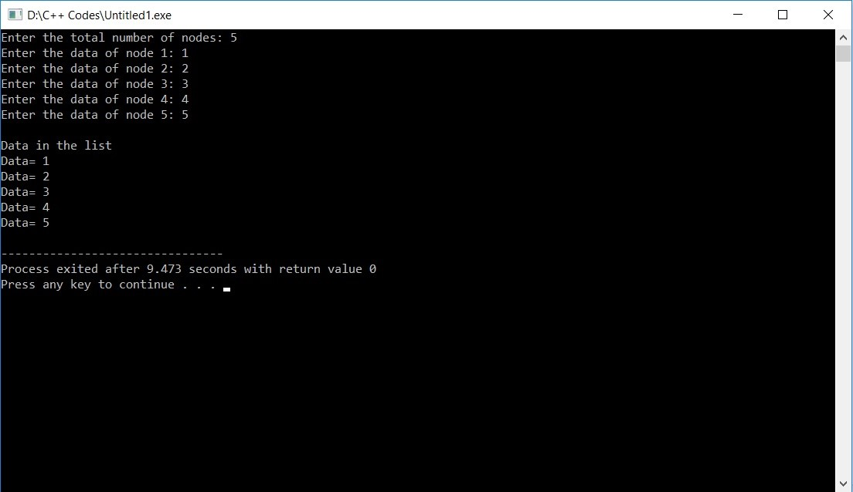

Figure 1: Link List

# Task

## Procedure: Task 1

Write a C++ code using functions for the following operations. 1.Creating a linked List. 2.Traversing a Linked List. Create a complete menu for the above options and also create option for reusing it.

**#include***<*iostream*>*

**#include** *<*stdlib .h*>* **using namespace** std ; **struct** node{ **int** data ; **struct** node ∗next ;

}∗head ;

**void** createList ( **int** n)

{

**struct** node ∗newNode,∗temp ; **int** data , i ; head=(**struct** node ∗) malloc ( **sizeof** ( **struct** node ));

**if** (head==NULL)

{

cout*<<*”Unable to allocatememory. ” ;

} **else**

{

cout*<<*”Enter the data of node 1: ” ; cin*>>*data ; head−*>*data=data ; head−*>*next=NULL; temp=head ;

**for** ( i =2;i*<*=n; i++)

{

newNode=(**struct** node ∗) malloc ( **sizeof** ( **struct** node ));

**if** (newNode==NULL)

{

|  |  |  |  |  |  |
| --- | --- | --- | --- | --- | --- |
| **break**;  } **else**  { |  |  |  |  |  |
| cout*<<*”Enter | the | data | of | node ”*<<*i*<<*” : | ” ; |

cout*<<*”Unable to allocatememory. ” ;

cin*>>*data ;

newNode−*>*data=data ; newNode−*>*next=NULL; temp−*>*next=newNode; temp=temp−*>*next ;

}

}

}

} **void** traverseList ()

{

**struct** node ∗temp ;

**if** (head==NULL)

{

cout*<<*”List is empty . ” ;

} **else**

{ temp=head ; **while**(temp!=NULL)

{

cout*<<*”Data=”*<<*temp−*>*data*<<*endl ; temp=temp−*>*next ;

}

}

}

**int** main()

{

|  |  |  |  |
| --- | --- | --- | --- |
| cin*>>*n;  createList (n ); |  |  |  |
| cout*<<*”\nData in | the | l i s t | \n” ; |

**int** n; cout*<<*”Enter the totalnumber of nodes : ” ;

traverseList ();

**return** 0;

}

# Conclusion

In this lab we learned how to create link list, its functioning and implementation. In this program we learned to create, insert and traverse a node to the link list.